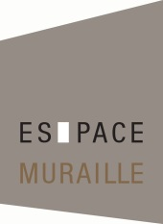
Press release

Espace Muraille presents
THE GRAINS WHIRL AND THE RIPPLES SHIFT
SHIRAZEH HOUSHIARY
Curator: Laurence Dreyfus

EXHIBITION: 11 May to 17 September 2016
Espace Muraille, Place des Casemates 5, Geneva

Tuesday to Friday, 10am–12 noon and 1pm–6pm
Saturday, 1pm–6pm
Closed Friday 27 May to Monday 6 June
Closed for summer holidays, Monday 11 July to Friday 15 August
Access: Buses 3 and 5 to Athénée

Opening: Tuesday 10 May from 6pm

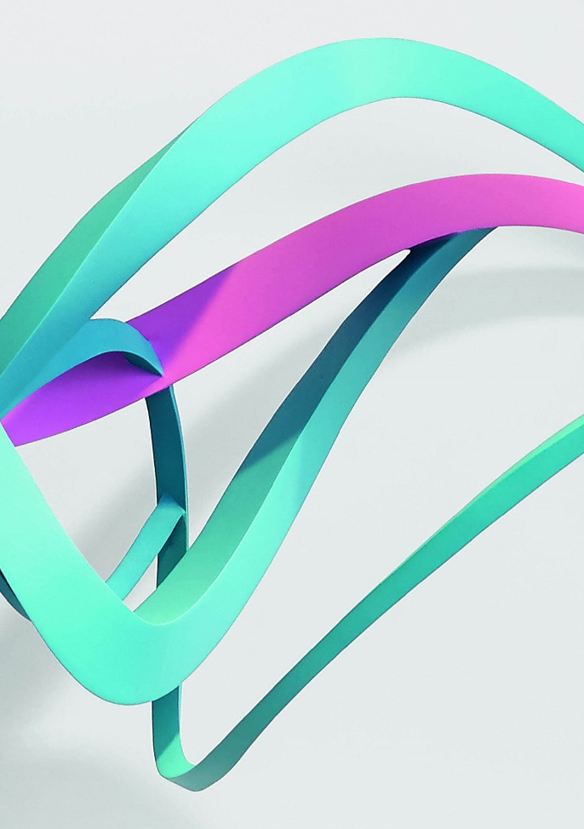

Shirazeh Houshiary’s swirling poetic universe enchants Geneva once again

GENEVA, xxx APRIL 2016 – Artist Shirazeh Houshiary, of Iranian origin and based in London, emerged in the 1980s as one of the major rising stars in contemporary sculpture, alongside Anish Kapoor and Richard Deacon. Since then she has extended her artistic range to incorporate multiple techniques, from painting to video. Houshiary’s works have been displayed in Geneva before – in the Musée Rath in 1988 – and she now takes the opportunity to feature her work at Espace Muraille. The artist was struck by the venue, which inspired her current project. Its title ‘The Grains Whirl and the Ripples Shift’ alludes to a poem by William Blake, Auguries of Innocence.

Giving shape to the intangible

‘To see a world in a grain of sand … hold infinity in the palm of your hand‘ – this was always at the heart of the Romantic poet and painter’s credo, just as it is for Houshiary and her plastic art. In the twinkling of an eye, that elusive mystery can take root in something vanishingly small – the absolute can be found in a fleeting emotion, a stirring of the soul.

Shirazeh Houshiary aims to ‘visualize and give shape to the intangible’, says Laurence Dreyfus, curator of the exhibition. ‘She carries us beyond the surface, to the evanescent, reality beyond shapes and what is visible.’ Her art is a whirlwind sweeping the onlooker away, or perhaps a meteorological phenomenon, a natural manifestation, a storm rising. The canvas crystallizes powerful and mysterious forces – those energies which gave birth to the universe. Houshiary’s motifs swirl like celestial bodies populating an improbable cosmos. Bruise, Pond, Seed, A deluge are some of these works carried by invisible forces and powered by atavistic energies.

Bruise, Pond, Seed, A deluge conjure up a comparable array of abstract landscapes – in dominant blues, deep purples and pinks – landscapes which are still inhabited. The infinitely small inspected under a microscope, or possibly images captured by a space probe… or when the minuscule meets the immeasurable.

A rare production

Shirazeh Houshiary devised the staging of her exhibition around a range of different sites. Fifteen works in a variety of formats are exhibited, paintings for the most part but also two animations and a metal sculpture.

This sculpture, Pitch, suggests a dancing ribbon or the curve of a wave, and is located in the stairway. The exhibition poster reproduces a detail of this sculpture, which seems to be carried along by a vital poetic life force.

As a general rule, Houshiary produces works very sparingly, with each work taking months to create. Laurence Dreyfus explains ‘In her London studio, she works on the bare floor with pencils and pigments which she applies straight onto the canvas, surrounded by art, poetry and music books.’

When she starts out on a new painting, she always uses an acrylic background, black or white, upon which the artist lightly inscribes two words in pencil, one asserting what the other denies. Fine skeins of coloured pigment are then superimposed on the writing and gradually intertwine and merge to form a diaphanous veil.

Veils are ever-present in Shirazeh Houshiary’s paintings, taking on the role of a membrane, a light skin separating our inside and outside and forcing the viewer to take up a position in order to interpret her work.

Words also play a fundamental role in Houshiary’s work. Language is what connects us to the world and defines us as individuals – a recurrent theme in the artist’s animations and especially in Breath, a symbolic work that attracted a great deal of interest at the Venice Biennale in 2013.

Breath is presented as a black cube calling to mind a confessional; the visitor goes inside the cube and hears songs of four different religions, while also experiencing the visual effect created by those voices.

Central themes: language and the veil

‘Language and the veil are central themes for the artist, who plays on them in order to show to what extent the fundamental aspect of reality is what we cannot see,’ says Caroline Freymond, director of Espace Muraille.

So, at the heart of Shirazeh Houshiary’s recent exhibition in Singapore, at the Singapore Tyler Print Institute, entitled ‘The River is Within Us’, her exploration of colour and paper brings to light words chosen from languages as varied as Hebrew, Sanskrit, Arabic, Mandarin and Latin.

Other sources of inspiration for Houshiary include Persian poetry and the rich culture of her native Iran, alongside Chinese painting and the Old Masters.

‘Even if Shirazeh dislikes being labelled as a “spiritual” artist, her work has a rare contemplative quality,’ Caroline Freymond adds. The gallery owner says ‘I’m particularly moved by its sense of equilibrium, its proximity to nature and the metaphysical dimension to her work, and the timeless quality of her painting in particular, which is so poetic and seems to open out onto the universe.’

Equilibrium in the face of chaos

For Shirazeh Houshiary, ‘the universe is in a process of disintegration, everything is in a state of erosion’ and her art simultaneously aims to ‘reach a point of equilibrium’.

Houshiary’s works can be found in a number of major public collections: MoMA, the Guggenheim, the Metropolitan Museum of Art and the British Council Collection, and the artist was also exhibited at the Venice Biennale (2013 and 1982), in Sydney (2010) and Kiev (2012), after being nominated for the Turner Prize in 1994.

She is renowned for her installations in public places, including the East Window of St Martin-in-the-Fields in London and also a number of her monumental sculptures, rather more prosaically situated in the flagship stores of Jimmy Choo and Victoria Beckham in London.

The exhibition at Espace Muraille was devised in collaboration with the Lisson Gallery in London. Laurence Dreyfus curates the exhibition for the third time, following the two outstanding personal exhibitions dedicated to the work of Monique Frydman and Tomás Saraceno. The artist will be present at the opening and available for interviews in English.

HD ILLUSTRATIONS:
Pictures HD and Press documentation_Shirazeh Houshiary at Espace Muraille

Further information:
http://www.shirazehhoushiary.com/
www.laurencedreyfus.com

Practical information and how to get there:
www.espacemuraille.com
info@espacemuraille.com

Espace Muraille, Place des Casemates 5, 1204 Geneva
Tel.: +41 22 310 42 92
Fax: +41 22 310 42 93

Open Tuesday to Friday from 10am–12 noon and 1pm–6pm
Saturday, 1pm–6pm
Closed Friday 27 May to Monday 6 June
Closed for summer holidays, Monday 11 July to Friday 15 August
Access: Buses 3 and 5 to Athénée

Press office: pur pr, Christine Urfer, christine@pur-pr.com
Mobile : +41 78 619 05 00 Landline: +41 21 320 00 10

